Use Cases and Logical Architecture

* **XID:** X00119959
* **Name:** Eddy Ekofo
* **Project Title**: Multi-Lang Messenger

## Section 1: For Each Use Case:

|  |  |
| --- | --- |
| **Title (goal)** | Account Management (CRUD) |
| **Primary Actor** | Client, Server-Admin |
| **Story** | * The user registers a new account by providing their: Name, Age, Location, Native language, Gender, Occupation (Student, Doctor etc.). * User can login to account * Server checks permission, thus rejects or admits the user. * User can manage account (Delete, update or delete) |

|  |  |
| --- | --- |
| **Title (goal)** | Messaging |
| **Primary Actor** | Client, Server-Admin |
| **Story** | * The user logs in the system. * The system saves the user’s credentials through a cookie. * User A sends a text message by a HTTP post requests to User B * Server sends the text to Microsoft Translator API * Server receives HTTP response from MT API * Server records necessary data from the HTTP response and displays on the dashboard. |

|  |  |
| --- | --- |
| **Title (goal)** | Interact with data |
| **Primary Actor** | Admin, Server-Admin |
| **Story** | * The Admin logs in the system (With an admin account). * The Server ensure the user has special privilege to access the data. * The server displays the dashboard. * The server Admin queries for the desired data through the dashboard web interface. * Server returns the data in real-time to the Admin. |

## Section 2: Prototype Schedule, Winter Semester 2017

|  |  |
| --- | --- |
| Iteration #1, Complete 25/10/2017 | Account Management, Messaging |
| Iteration #2 Complete 15/11/2017 | Messaging |
| Iteration #3 Complete 13/12/2017 | Interact with data |

## 

## Section 3: Logical Architecture

Multi-Lang Messenger Azure Architecture:

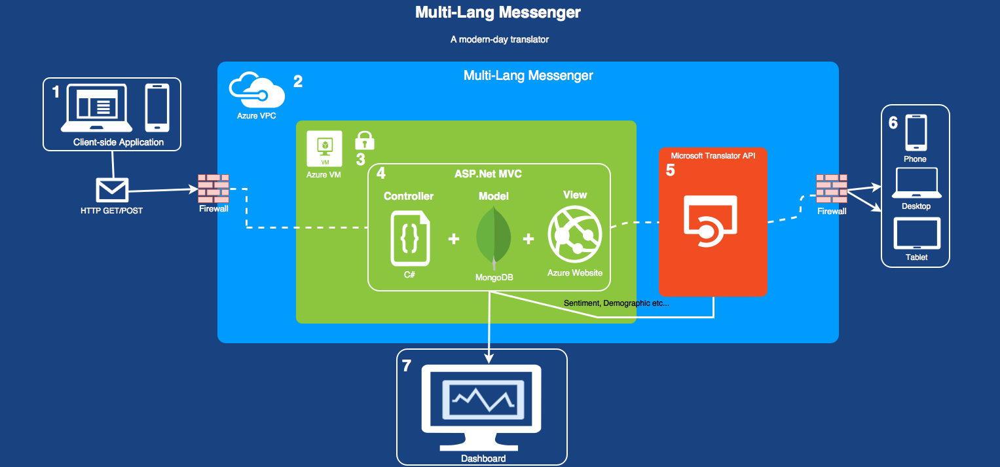

## Logical Architecture Discussion

**1: Client side application:**

Using Standard web development technologies such as HTML, CSS, JavaScript Libraries (JQuery, Vuejs) to build a front-end design which will be responsive according to the users platform e.g. Mobile or Desktop. Through this web interface the user will be enabled to make send HTTP requests to the server.

**2: Azure VPC:**

The Azure VPC is the cloud services which the application will be hosted through. Microsoft Azure provides a FireWall to all the requests made to it’s services, thus securing the services from any intruders which would harm the system.

**3 & 4: The Azure VM:**

I intent to build a Linux virtual machine (VM) using the cloud platform. The data base inside this VM will be MongoDB, if not, the equivalent NoSQL Database to store all the application data. Microsoft’s ASP.Net is the framework which I intent to use in the building of this application which will be hosted by Azure Websites.

**5: Microsoft Translator APIs:**

MT APIs is the core API which is used to enable translation or text and also to for sentiment understand of the users. This data is then used for the dashboard.

**6: Received text:**

The users receive the text in the desired language.

**7: Dashboard:**

The user’s sentiments are thus saved in the DB and are displayed in an intuitive dashboard for future management and marketing potentials